SIT123: Data Capture Technologies

# Setting Up The SD Card Activity Sheet

## 

## Hardware Required

* Arduino Board
* USB cable
* SD Card (SanDisk 8Gb Ultra SDHC Memory Card)
* Adafruit Assembled Data Logging Shield for Arduino (<https://tronixlabs.com.au/arduino/shields/sd-card/adafruit-assembled-data-logging-shield-for-arduino-australia/> )

## Pre-requisites: You must do the following before this task

**Read this sheet from top to bottom**

## Steps

The first step is to insert the SD card to the shield and stack the shield on top of the Arduino board. Follow the steps given below:

1. Find the SD card (16 GB) and the Data logger shield provided in the sensor kit.
2. Insert the SD card into the slot in the Data logger shield

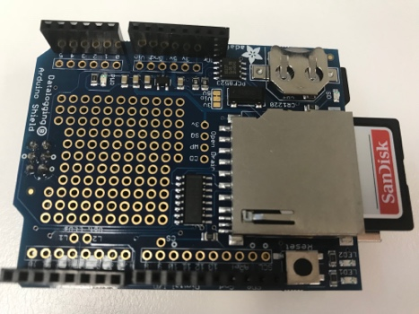

1. Stack the Data logger shield to the top of the Arduino board so that the pins are plugged in. Gently push to attach the shield.

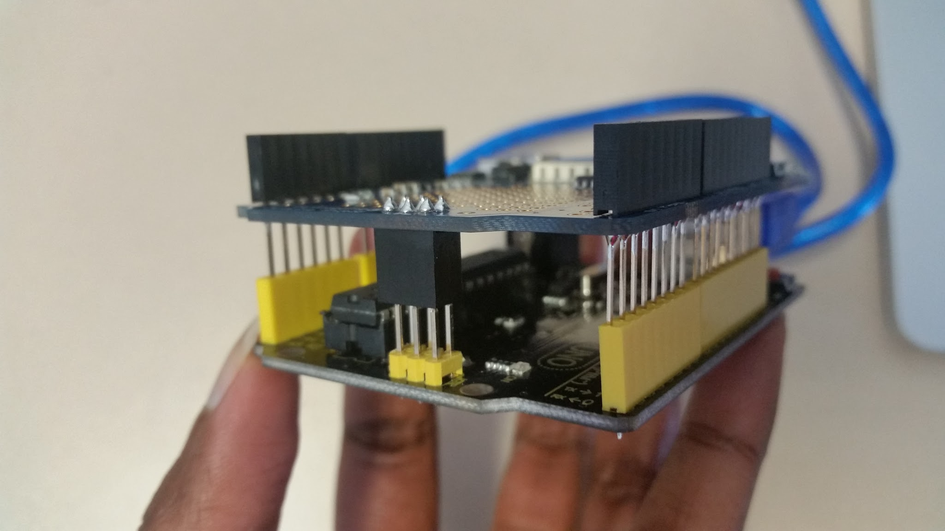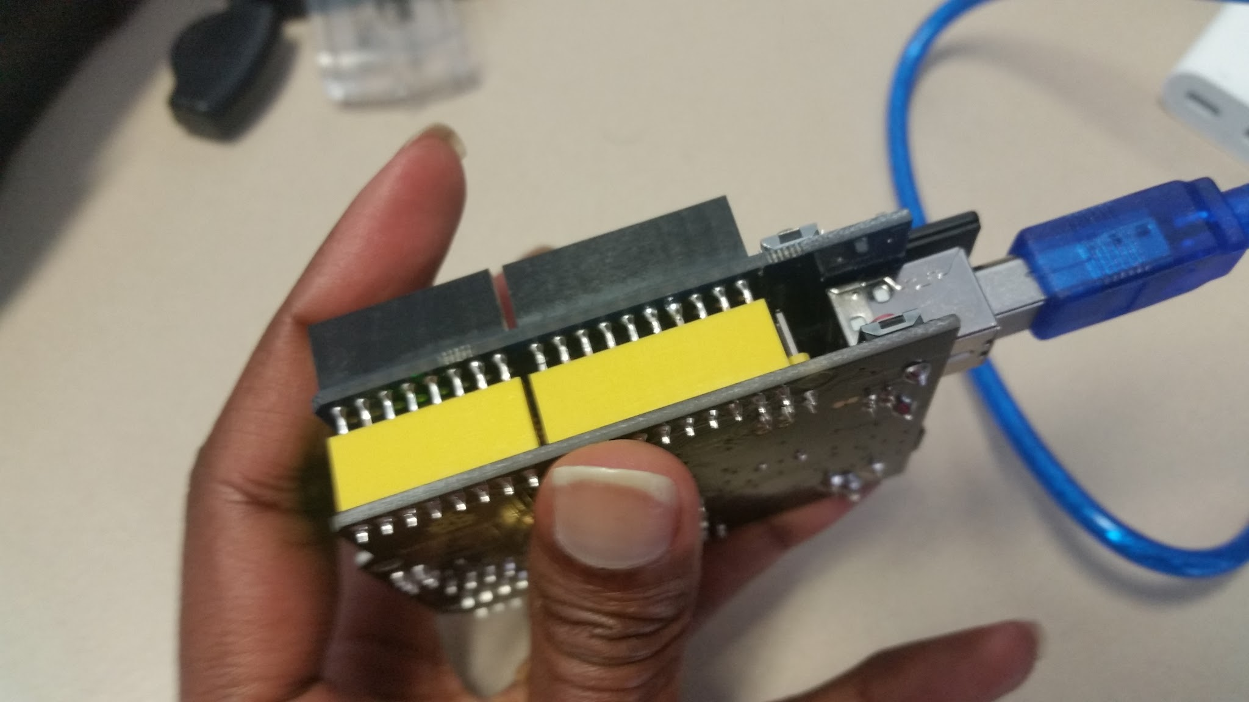

1. Attach the USB cable to the Arduino, and to the computer.

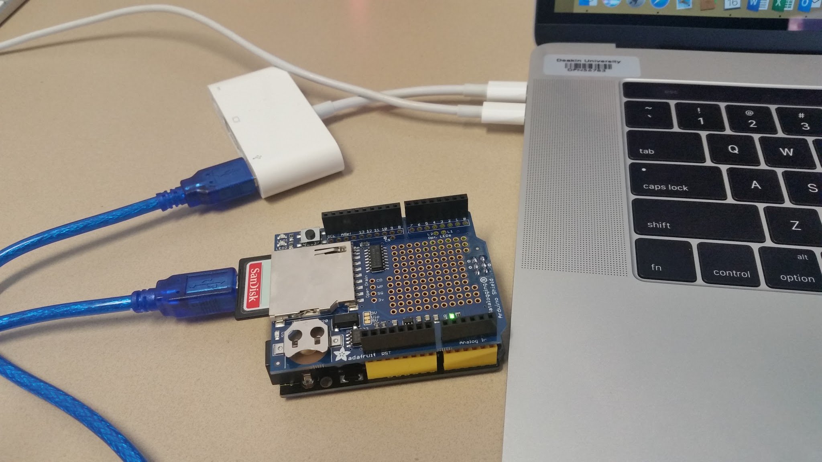

1. Now we need to make sure the SD card is properly inserted and supported. The Arduino SD Card library has a built in example that will help you test the shield and your connections. This sketch will not write any data to the card, just tell you if it managed to recognize it, and some information about it. This can be very useful when trying to figure out whether an SD card is supported.

Open the file CardInfo example sketch in the SD library:

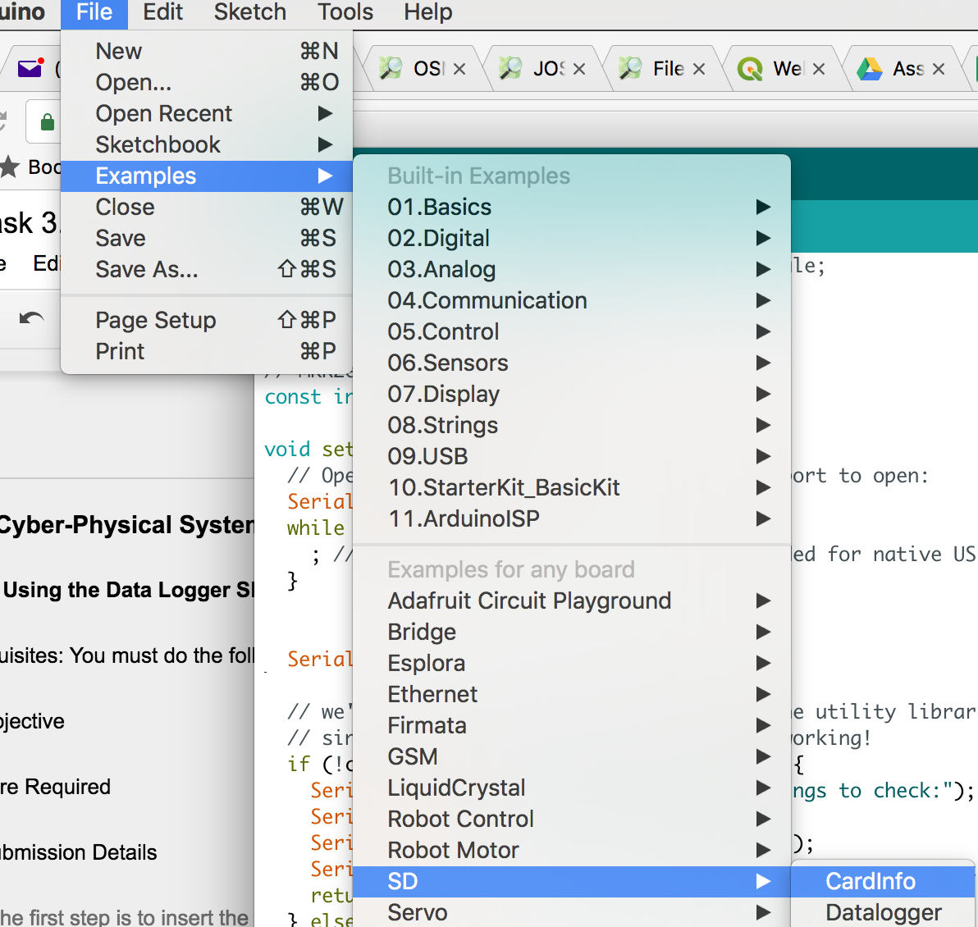

1. Go to the beginning of the sketch and make sure that the ***const int chipSelect*** line is correct, for the datalogger shield we're using digital pin 10 so change it to **10**. Save this sketch inside your sketch folder on the computer.
2. Verify and upload the sketch.
3. Open up the Serial Monitor. If all is setup correctly, you should see something like this:

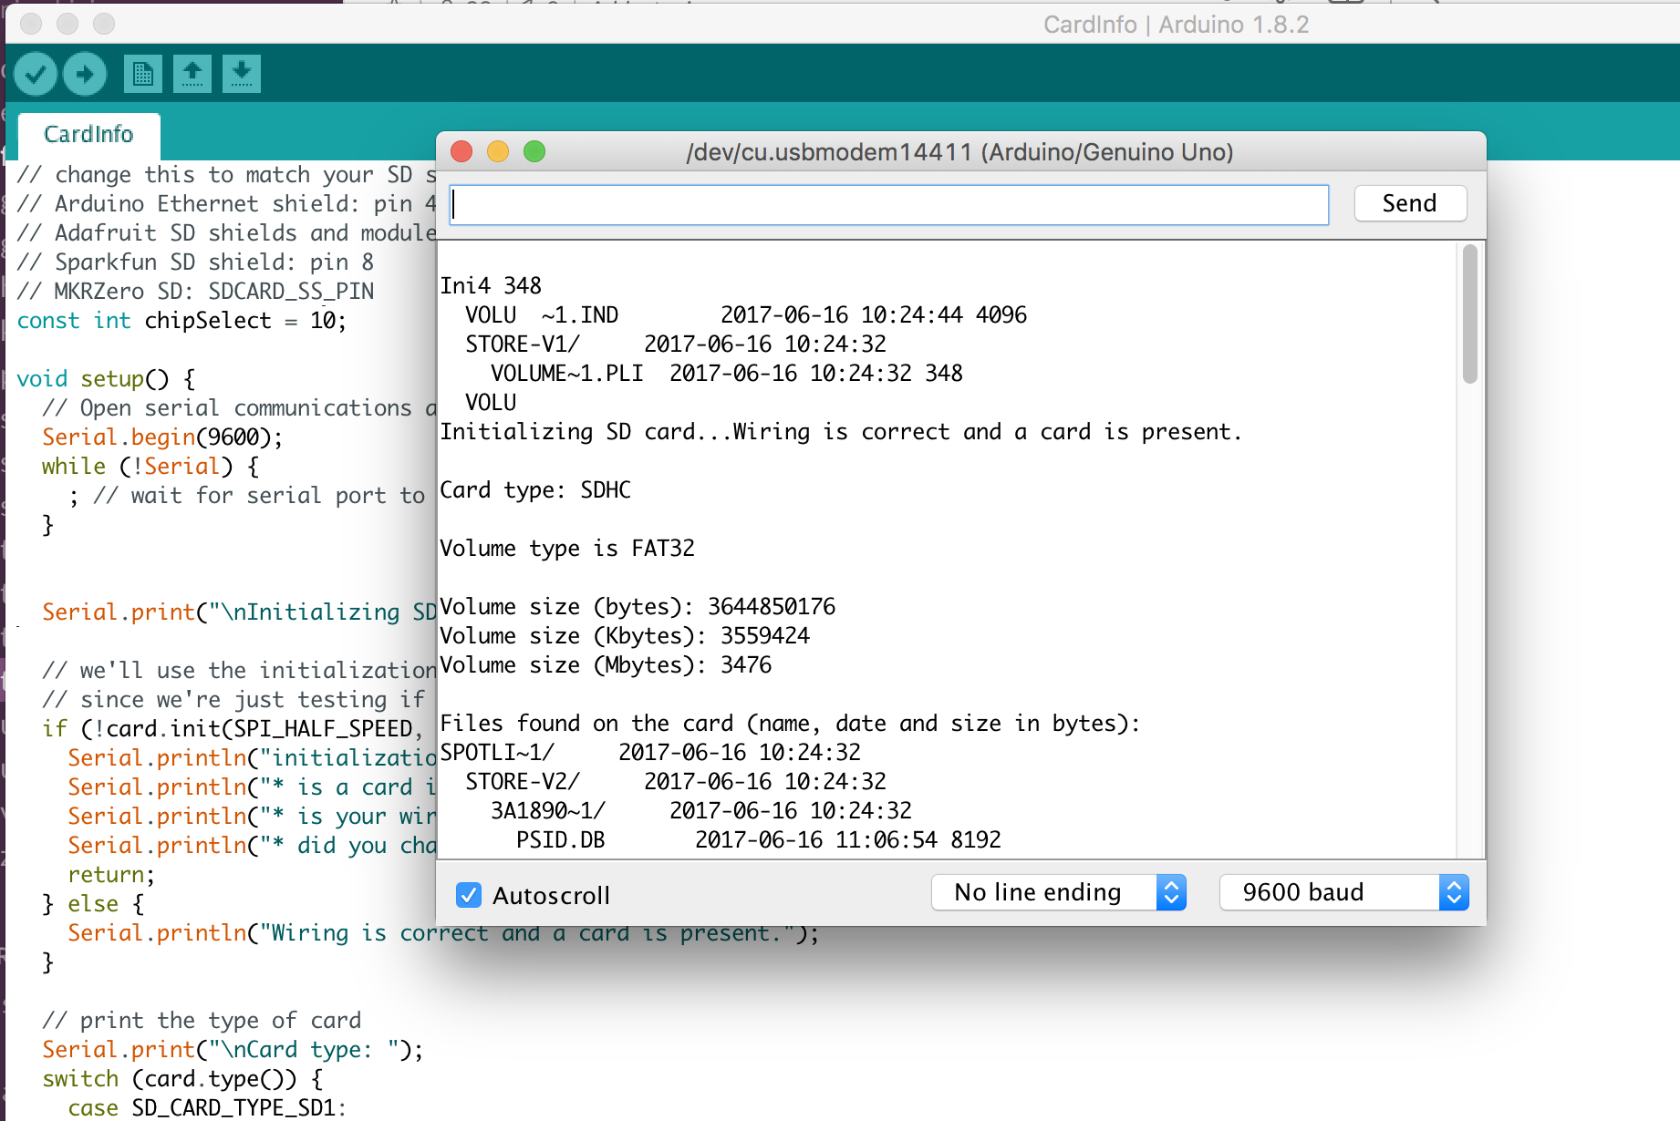

## References

<https://learn.adafruit.com/adafruit-data-logger-shield/using-the-sd-card>